4/1/2025

## Submitted by: Olivier Tsinda Takuete

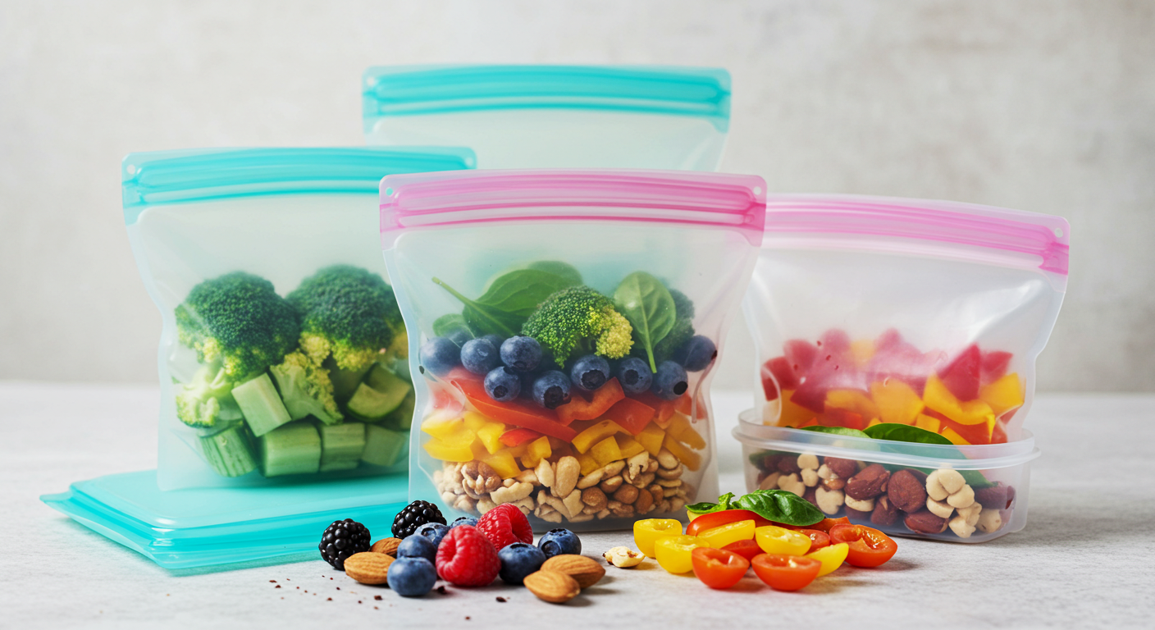

Reusable Silicone Food Bags:Marketing Strategy in Germany

|  |  |  |  |  |
| --- | --- | --- | --- | --- |
| Name: Olivier Tsinda Takuete | Week: | | Turn in a typed, fully completed form. Handwritten or late forms are not accepted. | |
| 0 points  A few terms & disconnected thoughts, badly written, simply stated agreement with others. | | 1-2 points  Copied readings or other students. Some thoughtful comments, fair writing. | | 2-3 points  Explained concepts – carefully constructed statements, thoughtful & well written. |
| Readings :Marketing Strategies for Sustainable Products, Consumer Psychology, and Eco-Friendly Innovations. | | | | |
| Overview  In our readings, we explored strategies used by companies to position sustainable products in eco-conscious markets. Companies must align their branding and operations with consumer values such as health, safety, and environmental impact. Particularly in Europe, labels like “Blue Angel” greatly influence purchase decisions. This certification builds trust and is essential for entry into the German sustainable goods market. | | | | |
| Summary :300 & 400 and Graduate Level Courses (~500 words)  The readings offered deep insight into how modern brands can connect with environmentally aware audiences, particularly in markets like Germany where eco-values dominate purchasing decisions. Analyzing companies that succeeded in green economies revealed that trust-building through certifications, transparent messaging, and policy compliance is paramount. The case of reusable silicone bags aligned perfectly—positioned as a sustainable, cost-effective, and policy-compliant alternative to disposable plastics.  One striking theme was how eco-conscious consumers are not just driven by savings, but by purpose. Brands succeed when they reflect personal values, offering not just a product but a promise. For example, our “Break It, We Replace It” guarantee isn’t just about durability—it’s a statement of trust and quality assurance.  Marketing in such a space demands a smart, omnichannel approach. Social media challenges, B2B outreach for zero-waste certifications, and in-store demo campaigns are effective at capturing both hearts and leads. Moreover, personalization through QR-code based email collection and loyalty incentives amplifies conversion and retention. The readings also explored the importance of delivering world-class experiences post-purchase—loyalty programs, referral bonuses, and customer education on sustainability fuel ongoing engagement and brand advocacy.  Ultimately, the take-home message was clear: sustainability and profitability are not mutually exclusive. Brands like ours can thrive by being aligned with evolving regulations and consumer consciousness, especially in forward-thinking markets like Germany. | | | | |
| Learning Outcomes  1. I Learned to align product branding with sustainability and consumer values.  2. I understood how regulatory frameworks like Germany’s Plastic Tax impact marketing strategy.  3. Developed integrated multi-channel campaigns tailored to eco-conscious users.  4. Understood the impact of certifications in marketing and guarantees to build long-term brand trust.  5. Learned digital engagement strategies that drive referrals and brand loyalty. | | | | |

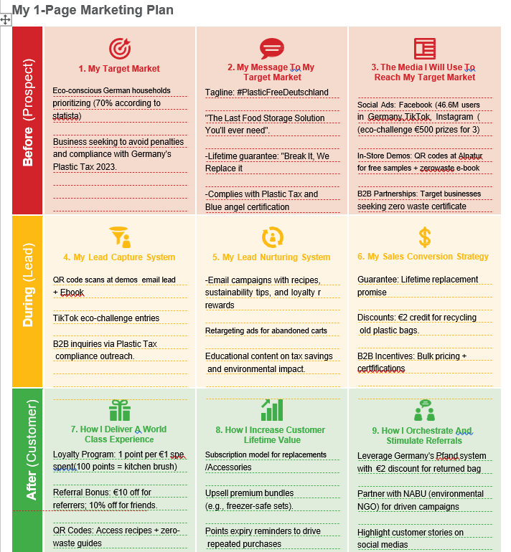

AVATAR

## **Eva Müller – The Eco-Conscious German Mom** **Demographics:** 35 years old, Berlin-based, middle-income, married with two children.

## **Values & Behavior:**

## Prioritizes sustainability; 70% of Germans like her choose eco-friendly products for their families (Statista).

## Shops at Alnatura and relies on trusted labels (Blue Angel) to validate product claims.

## Actively seeks alternatives to single-use plastics, frustrated by frequent repurchases and waste.

## **Solution Fit:** Reusable silicone bags save her €200+ annually vs. disposables, comply with Germany’s sustainability policies(Plastic Tax 2023), and align with her daily rituals (e.g., packing *Brotzeit* lunches).

## EVA- OUR IDEAL CUSTOMER

**Eva** is a 35-year-old mother living in Berlin, representing a large demographic of German consumers prioritizing eco-sustainability. As a loyal Alnatura shopper, Eva values certified green products like ours with Blue Angel labels. She’s tech-savvy, socially engaged, and heavily influenced by eco-conscious communities.

Eva has been frustrated with plastic waste and is actively seeking plastic-free alternatives. Our reusable silicone bags offer her a solution that’s cost-saving, safe, and future-friendly. She responds well to QR-based interactions, lifetime guarantees, and content that educates her family on sustainable living.

Eva represents our ideal customer—a voice in the green movement who seeks convenience, values, and community impact.

My Target Market

My target market includes eco-conscious German households—especially women aged 30–45 with children—who are committed to reducing plastic waste. Statista reports that 70% of German families prioritize sustainable purchases. These customers shop at organic stores like Alnatura and value trustworthy certifications like Blue Angel.

They seek products that align with family health, sustainability, and future readiness. Our marketing strategy connects directly with their values using educational demos, emotional guarantees, and financial incentives like plastic tax compliance. Germany’s policy environment makes our reusable solution not only desirable but necessary. We connect with shoppers who demand both values and verification.

Eco-Conscious Households & Compliance-Driven Businesses

* **Households:**
  + 70% of Germans prioritize sustainability (Statista), spending €128/year on eco-products (Green Economy Report 2024).
  + Pain Points: High costs of disposables, frustration with single-use waste, demand for durable solutions.
* **Businesses:**
  + Impacted by 2023 Plastic Tax (€0.80/kg levy on non-recyclables).
  + Seek Zero-Waste Certifications to avoid penalties and enhance brand reputation.
* **Cultural Alignment:**
  + Germany’s Pfand system (bottle deposits) primes consumers for recycling incentives (€2 discount for returned bags).

My Message to the Target Market

Our message is simple and strong: **"The Last Food Storage Solution You'll Ever Need**." It highlights our product’s durability, safety, and zero-waste promise. We reinforce trust with a lifetime guarantee of **“Break It, We Replace It”** and the Blue Angel certification—a must-have for German eco-shoppers. Emotionally, we emphasize family health and environmental responsibility. Financially, we show yearly savings of over €200 and plastic tax avoidance.

Our tagline **#PlasticFreeDeutschland** builds community and movement identity. Through storytelling, testimonials, and social media advocacy, we connect personally while demonstrating social and policy alignment.

## #PlasticFreeDeutschland: Building Trust & Urgency

* **Core Message:** “The Last Food Storage Solution You’ll Ever Need.”
* **Supporting Pillars:**
  1. **Cost Efficiency:** Save €200+/year vs. disposables (Zhetimes.com).
  2. **Policy Compliance:** Avoid Plastic Tax penalties; Blue Angel certification ensures credibility.
  3. **Environmental Impact:** Reduce plastic waste in ecosystems; partner with NABU for park benches made from recycled bags.
  4. **Quality Assurance:** Lifetime replacement promise withstands -40°C to 240°C (microwave, freezer, oven-safe).

The Media I Will Use to Reach My Market

We will reach our market using a mix of digital and in-person channels. Key platforms include

**Facebook (46.6M users in Germany), TikTok, and Instagram**, especially through eco-challenges and influencer partnerships. These platforms help us spark trends and generate user-created content.

In-store demos at **Alnatura** provide trusted physical engagement, with QR codes linking to free zero-waste ebooks and recipe guides.

**B2B outreach** will target businesses striving for Zero-Waste Certification, appealing to Germany’s policy-driven market. Our media strategy blends viral engagement, personal interaction, and institutional value.

**Multi-Channel Strategy to Maximize Reach**

1. **Social Media Ads:**
   * **Facebook:** Target 46.6M users (51.7% women, 48.3% men) with carousel ads showcasing durability and savings.
   * **TikTok Eco-Challenge:** Encourage users to share creative uses of silicone bags; top 3 winners earn €500 (virality + UGC).
2. **In-Store Demos at Alnatura:**
   * Shoppers scan QR codes to claim **free samples** and a **zero-waste e-book** (recipes + sustainability tips), capturing email leads.
3. **B2B Outreach:**
   * Partner with businesses needing Plastic Tax compliance; offer bulk pricing and certifications to secure long-term contracts.

Summary of My 3 Marketing Campaigns

1. **TikTok Eco-Challenge:** Encourages users to share their plastic-free habits. Top 3 winners receive €500, generating buzz and User Generated Content.
2. **Alnatura In-Store Demo Campaign:** QR codes on demo tables link to free zero-waste guides, capturing emails and trust in an authentic setting.
3. **B2B Compliance Campaign:** Direct outreach to German businesses to offer reusable bags as a tax-saving and sustainability solution. We include bulk pricing and compliance certificates Each campaign is designed to generate leads, build credibility, and spark long-term relationships.

3 Marketing Campaign Strategies  
**1. TikTok Eco-Challenge (#PlasticFreeDeutschland):**

* **Goal:** Viral engagement + brand awareness.
* **Mechanics:** Users post videos using silicone bags; 3 winners receive €500.
* **Outcome:** Leverage User Generated Content for retargeting ads; estimated 10K+ entries.

**2. Alnatura QR Code Campaign:**

* **Goal:** Lead generation + trust-building.
* **Mechanics:** Shoppers scan QR codes in-store for free samples and e-book.
* **Outcome:** 5K+ email leads/month; nurture via recipe emails and loyalty rewards.

**3. B2B Plastic Tax Compliance Drive:**

* **Goal:** Secure bulk B2B contracts.
* **Mechanics:** Outreach to 500+ businesses via LinkedIn and trade shows; highlight tax savings and certifications.
* **Outcome:** 50+ B2B clients in Year 1, driving 21% of revenue.

World-Class Experience

We create a world-class experience through quality, transparency, and education. Our lifetime replacement guarantee ensures confidence from the first purchase. Customers gain access to exclusive content—eco-recipes, zero-waste tips, and sustainability webinars. Loyalty programs reward every purchase, while our responsive support channels—live chat, email, and social—offer real-time help.

We foster community through social storytelling and highlight customer journeys. Our Pfand-style recycling discount reflects familiar cultural rituals. Through every touchpoint, customers feel valued, understood, and empowered to live sustainably.

## Loyalty, Sustainability, and Seamless Engagement

* **Lifetime Guarantee:** “Break It, We Replace It” reduces purchase anxiety.
* **Recycling Program:** €2 discount for returning old bags, which are recycled into new products.
* **Loyalty Rewards:**
  + 1 point per €1 spent; 100 points = free kitchen brush.
  + Points expiry reminders drive repeat purchases.
* **Digital Integration:** QR codes unlock recipes, zero-waste guides, and exclusive content.

How I Will Increase Client Lifetime Value

We boost Client Lifetime Value (CLV) through subscriptions, upselling, and consistent engagement. We offer a **reusable bag subscription** for replacements and accessories. Upsell bundles include freezer-safe sets and gift packs. Customers earn points for purchases, redeemable for eco-kitchen tools.

Referral bonuses and seasonal offers drive retention and word-of-mouth. We send personalized emails with tips and loyalty updates. Our brand grows with the customer—new products, evolving incentives, and emotional loyalty turn first-time buyers into lifelong advocates. By 2026, we project doubling revenue through these long-tail strategies.

## Scaling Revenue Through Retention & Advocacy

* **Subscription Model:** Auto-replenish replacements/accessories (e.g., seals) every 6 months.
* **Upsell Premium Bundles:** “Freezer-Safe Set” (€49) vs. basic €29 starter kit.
* **Advocacy Programs:**
  + Referral rewards: €10 off for referrers; 10% off for friends.
  + Partner with NABU to showcase customer impact (e.g., “X bags recycled = 1 park bench”).
* **Financial Goal:** Double revenue by 2026 (€38K → €100K+) via B2B subscriptions and loyalty-driven retention.

[1]

1. **1. Statista (German Eco-Conscious Consumers)**

   **Reference:** "70% of Germans prioritize eco-sustainability for their families."

   **Link:** [Statista – Sustainability in Germany](https://www.statista.com/topics/6139/sustainability-in-germany/)

   **3. Zhetimes.com (Cost Savings Claim)**

   **Reference:** "Germans save €200+/year switching to silicone bags."

   **Link:** The URL fragment zhetimes.com/uk/science/air/plastic- from [WRAP UK](https://wrap.org.uk/) or [Zero Waste Europe](https://zerowasteeurope.eu/)

   **4. NapoleonCat (Social Media User Data)**

   **Reference:** "46.6M Facebook users in Germany (2024)."

   **Link:** [NapoleonCat – Facebook Users in Germany](https://napoleoncat.com/stats/facebook-users-in-germany/2024/)

   **5. Blue Angel Certification**

   **Reference:** Germany’s eco-label for sustainability compliance.

   **Link:** Official site – [Blue Angel Certification](https://www.blauer-engel.de/en)

   **6. 2023 German Plastic Tax**

   **Reference:** €0.80/kg levy on non-recyclable plastics.

   **Link:** German government source – [Federal Ministry for the Environment](https://www.bmu.de/en/topics/waste-resources/product-responsibility/plastic-tax/)

   **8. Pfand System (Bottle Deposit System)**

   **Reference:** Germans’ familiarity with recycling incentives.

   **Link:** [German Pfand System Explained](https://www.germany.info/us-en/service/04-FactsAboutGermany/-/944900)